**Inventory - Scenario 1:**

**Warehouseman added a new product to the system - milk and updated the system about 3 new milk boxes that arrived to the store.**

**- the object diagram is after action performed- strongly satisfiable**

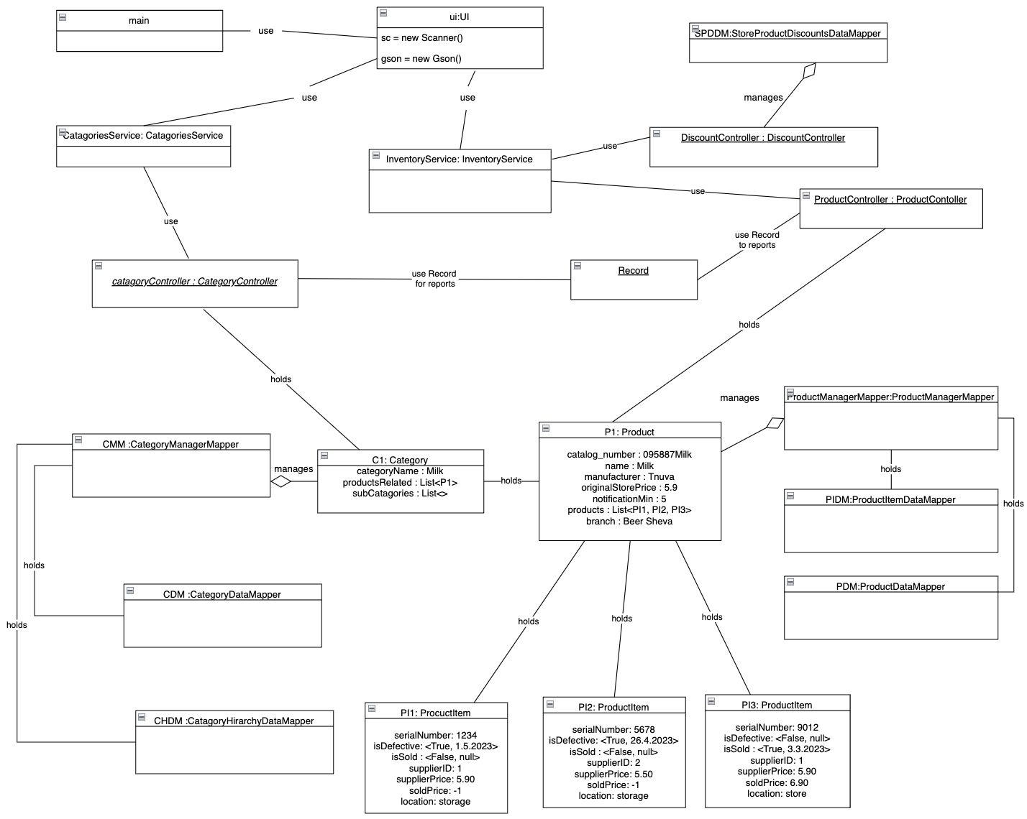

**Inventory - Scenario 2:**

**Now,the warehouseman is adding 3 sub categories under the milk category.**

**- the object diagram is after action performed- strongly satisfiable**

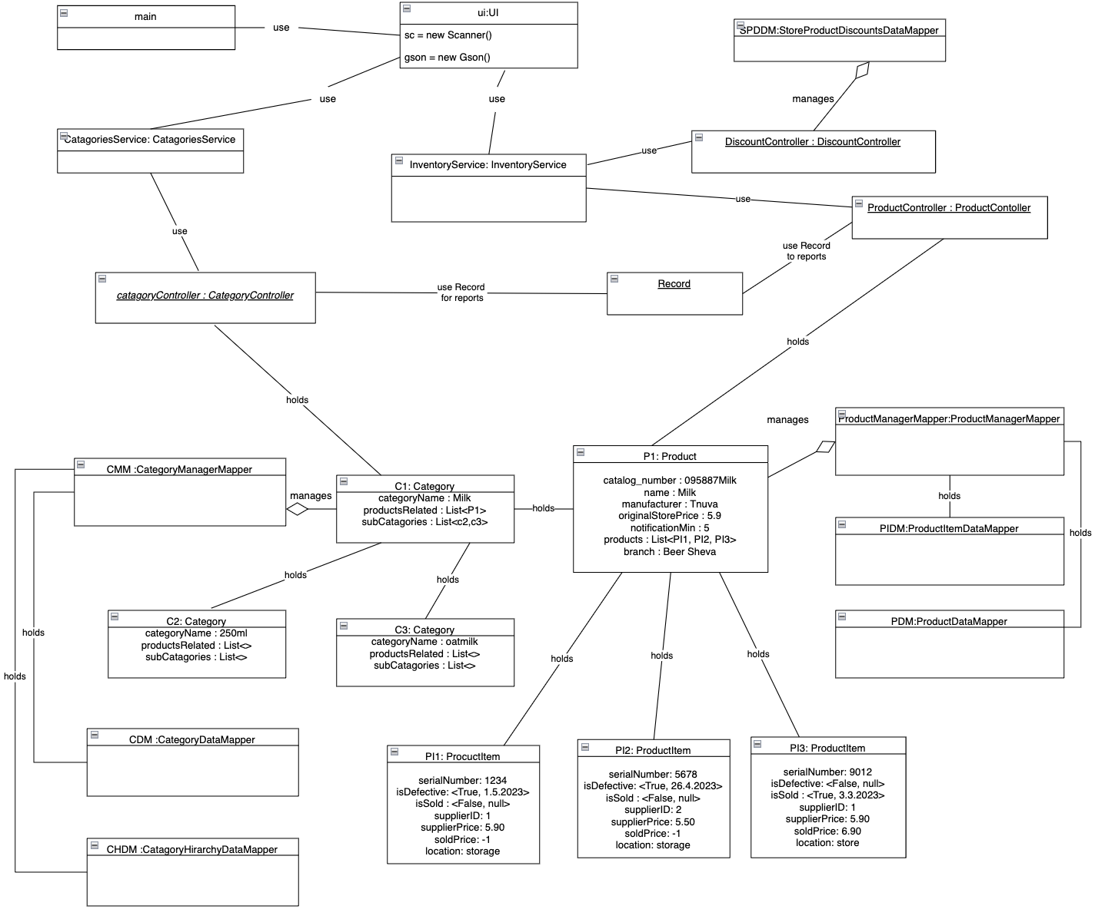

**Suppliers - Scenario 1: User order 900 milk and the system contains one supplier**

**- the object diagram is after action performed- strongly satisfiable**

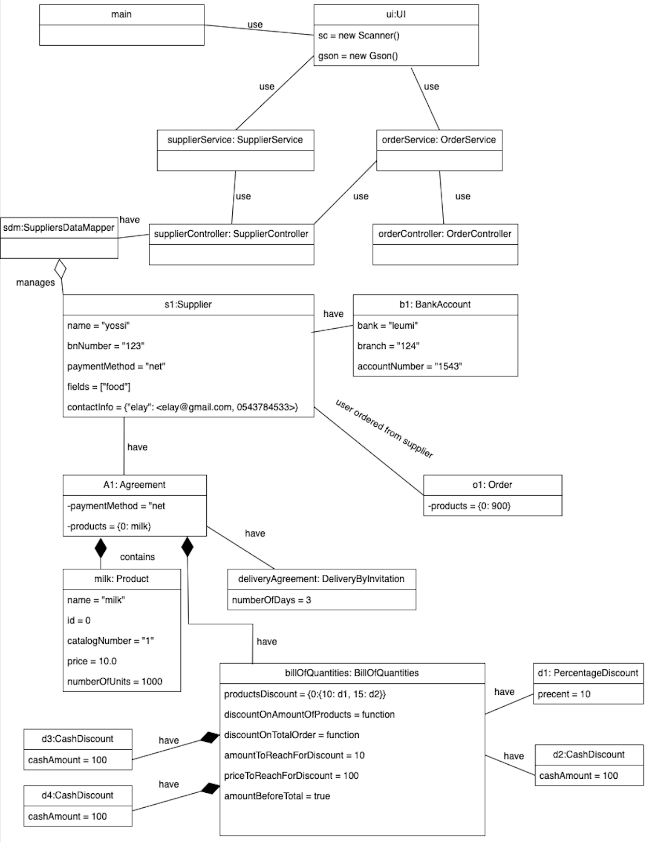

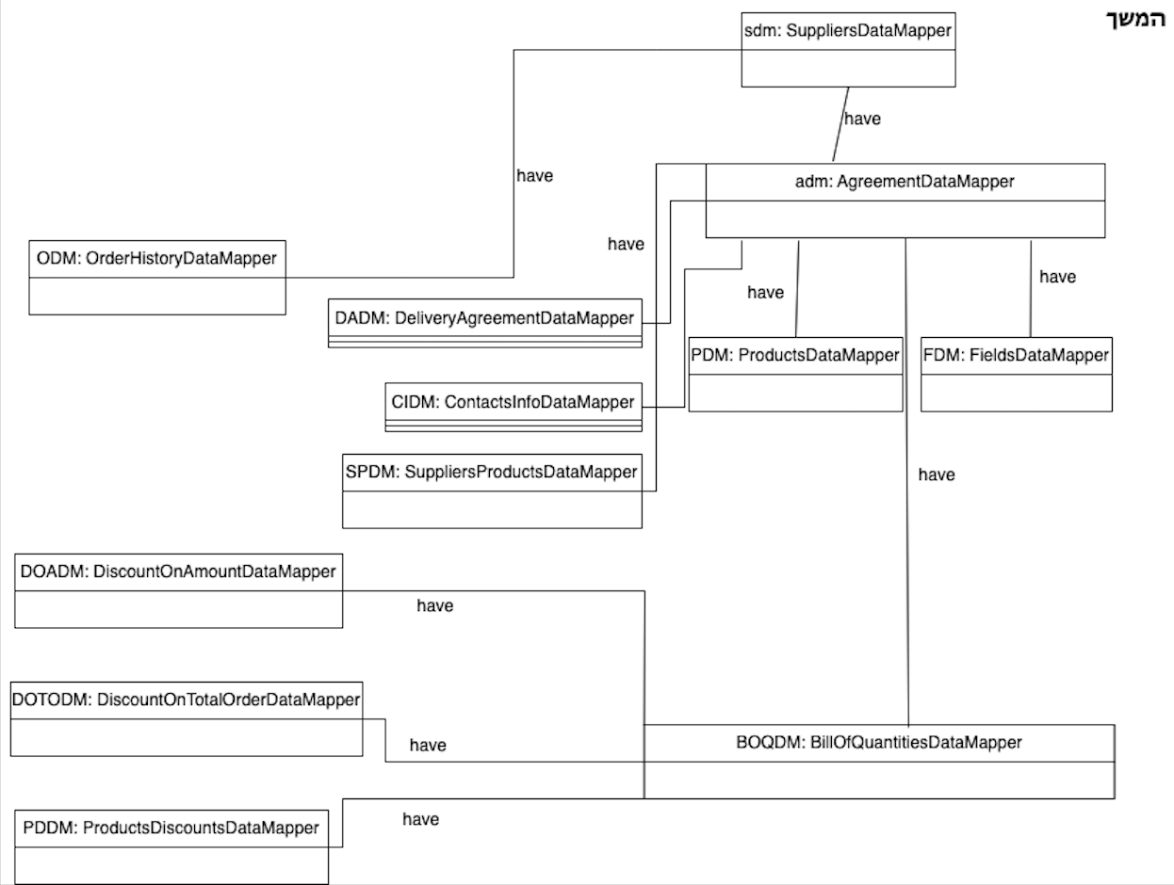

**Suppliers - Scenario 2: user adds new supplier to the system the supplier can supply product "milk"**

**- the object diagram is after action performed- strongly satisfiable**

